Charcuterie:
A glorious arrangement of unique, fun foods, presented as one large ensemble, where guests gather and mingle
while enjoying delightful, exquisite treats.
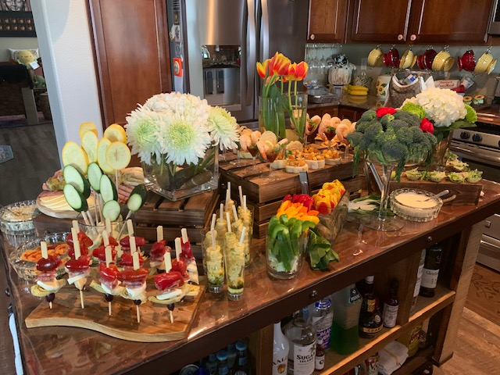.
Menu as Pictured
Artisan Breads, Gourmet Crackers, Tapenade, Assorted Spreads
Vegetable Crudites with Assorted Dips
Caesar Salad Cups
Stuffed Date Spoons
Antipasto Skewers
Tortellini Shooters
Caprese Chicken Roll
Shrimp Cocktails
Assorted Fine Deli Meats and Cheeses

$75 Per Guest Plus Tax and Set Up Fees

