Annie’s Gourmet Budget Dinner Buffet

Caesar Salad

Chopped romaine, shaved parmesan, topped with homemade garlic croutons
Assorted Rolls and Butter

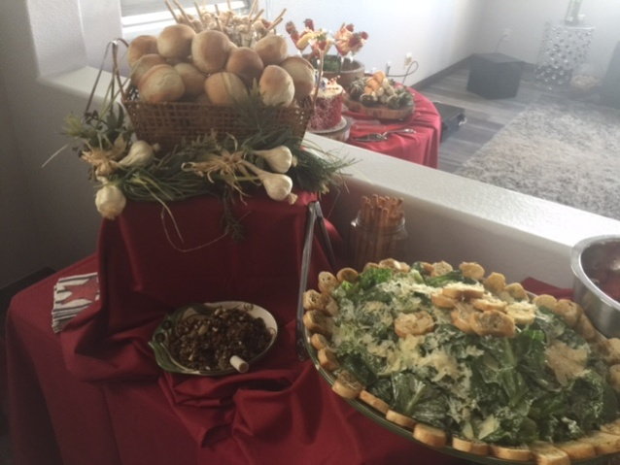

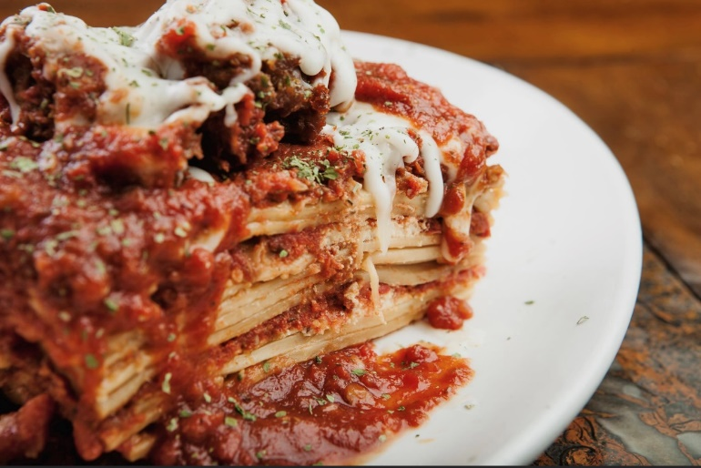
Chicken Parmigiana

Meat Lasagne

Fettucini Alfredo

Mini Cannoli

$30 Per Guest Plus Tax and Delivery (No Amenities)
Minimum Guest Count of 25 Required

Additional Set Up Fees and Minimums apply for Full-Service Events
Full Service includes Heated Chafers, Fuel, Serving Utensils,
Disposable Plates, Napkins, and Cutlery

